TÖL502M - Samskipti manns og tölvu

Group 10

11/10/20



HÓ1 - Book delivery service

Kim Stroem, Pétur Freyr Kristmundsson, Rökkvi Steinn Finnsson, Sigríður Ösp Green Sigurðardóttir

**Chapter 1 - Case Challenge** **3**

**Chapter 2 - Insight** **3**

Learn Method: Activity Analysis - Pétur 3

Tasks 3

Actions 4

Objects 6

Performers 6

Interactions 7

Results 7

Learn Method: Character profiles - Sigríður 7

Profiles 8

Results 9

Look Method - Activity Behavioral Archeology - Kim 9

Using the Activity 10

Results 11

Look Method - Fly on the Wall - Rökkvi 11

Results 12

Additional thoughts 13

**Chapter 3 - Sketches** **13**

Initial sketches 14

**Chapter 4 - Roles** **16**

**Chapter 5 - The Prototype** **16**

**Chapter 6 - Test** **22**

Ask method - Surveys & Questionnaires - Pétur 22

Types of questions: 22

The Survey 22

Survey outcome 25

Results 28

Ask method - Extreme User Interviews - Kim 29

Description and Motivation 29

Using the Activity 29

Results 30

**Chapter 7 - Conclusion** **31**

# **Chapter 1 - Case Challenge**

Our group’s challenge was to create a service that lets residents in Reykjavik and the surrounding area order library books for home delivery and pick-up with a focus on having the service environmentally friendly and sustainable. Upon receiving the information the group set up a group chat in messenger and a planning board in Asana. Two Look methods and two Learn methods were doled out and we decided to meet again the next week to review our findings and compare prototypes.

# **Chapter 2 - Insight**

## Learn Method: Activity Analysis - Pétur

The first Learn activity that we chose is “**Activity Analysis**” which was worked on by Pétur.

This activity consists of listing all tasks, actions, objects, performers and interactions involved in a particular activity. According to the IDEO cards this is a useful way to identify everything that relates to the project, which people you should aim to interview first and what problems have to be addressed.

We performed the activity and analyzed all of the tasks, actions, objects and performers that relate to the process of a customer going to the library and borrowing or returning a book.

The following are the results from performing the activity:

### **Tasks**

In this chapter we list all **tasks** that relate to a customer going to the library and borrowing and/or returning a book.

* ***Tasks*** from the perspective of the **customer:**
  + **Borrowing a book**:
    - Transportation
      * Go to the library.
      * Go home from the library.
    - Find a book
    - Apply for a Library card
    - Pay late fees (if there are any).
  + **Returning a book:**
    - Transportation
      * Go to the library.
      * Go home from the library.
    - Pay late fees. (if there are any)
    - Borrow a new book.
* ***Tasks*** from the perspective of the **library employee:**
  + **When customer is borrowing a book:**
    - Welcome customer.
    - Help customers find a book.
    - Register the book to the customer.
    - Charge late fees. (if there are any)
  + **When the customer is returning a book:**
    - Welcome customer.
    - Register the book as returned.
    - Put the book back to where it is supposed to be in the library.
    - Register a new book to the customer if they want to borrow a new book.
    - Charge late fees. (if there are any)

### 

### **Actions**

In this chapter we list all **Actions** that relate to a customer going to the library and borrowing and/or returning a book.

* ***Actions*** from the perspective of the **customer:**
  + **Borrowing a book**:
    - Transportation.
      * Go to the library.
      * Go home from the library.
    - Find a book
      * Look at different books and find one that is interesting.
      * Take the book if it is available.
      * If the book is currently out with another customer, wait for the book to be returned and borrow at a later date.
    - Take book to the register.
    - Library card
      * Apply for a library card.
      * Show library card.
    - Pay late fees (if you have any)
    - Talk to library employees.
  + **Returning a book:**
    - Transportation
      * Go to the library.
      * Go home from the library.
    - Pay late fees (if there are any)
    - Talk to library employees
    - Borrow a new book.
* ***Actions*** from the perspective of a **library employee:**
  + When customer is **borrowing a book**:
    - Welcome customer.
    - Help customers find a book.
      * Check to see the status of a specific book.
        + Location in the library.
        + See if it is in the library, or currently with another customer.
      * Physically search for the book.
    - Scan the book into the computer system and register the book to the customer.
    - Charge late fees if the customer has any.
  + When the customer is **returning a book**:
    - Welcome customer.
    - Receive the returned book.
    - Register the book as returned.
    - Look up where the book is supposed to be in the library.
    - Put the book back to where it is supposed to be.
    - Register a new book to the customer if they want to borrow a new book.
    - Charge late fees if the customer has any.

### **Objects**

In this chapter we list all the **objects** that relate to a customer going to the library and borrowing and/or returning a book.

* Books.
* Bookshelves.
* Mode of transport
  + Car.
  + Bike.
  + Public Transportation.
* Register.
* Computer system.
* Scanner.
* Credit card / Money.
* Library card.

## 

### **Performers**

In this chapter we list all the **performers** that are related to a customer going to the library and borrowing and/or returning a book.

* Customer
  + Person seeking to borrow a book.
  + Person that already has borrowed a book.
* Library employees
  + Librarian.
  + Person in charge of inventory.
  + Lobby personal

### **Interactions**

In this chapter we list all the possible **Interactions** that appear between people when a customer goes to the library and borrows and/or returns a book.

* Customer <-> Public transport.
* Customer <-> Library employees.
* Customer <-> Other customers.
* Library Employee <-> Computer System.

### 

### Results

After applying the “***Activity Analysis***” we can see that the main performers in this case are the customer and library employee. Thus, it would be important to interview multiple library employees and customers about their experience around borrowing or lending books. By doing so we would be able to shine a light on problems that occur during the process, as well as preventing potential problems that might come up during our project.

The main issue we must address with our project is the time commitment that it takes for the customer and employee to borrow a book and return it. There must be a way to minimize the time commitment for both parties.

## Learn Method: Character profiles - Sigríður

The second Learn exercise was done by Sigríður. They chose to do Character Profiles to get a better idea of the type of person that commonly visits the library to get a clearer view of what kind of person would be using the product. They felt that character profiles would be a good choice for our product seeing as the target market for it is very large and it would be good to identify commonalities between the variety of people who use the library often. The observations came mainly from Sigríður and a former librarian at the Icelandic National Library.

### **Profiles**

* University student - Brent Johnson
  + Brent Johnson (22) is a university student in his second year of the anthropology program with the University of Iceland. He enjoys skiing and going out with his friends. Every other weekend he works part time as a server at a restaurant. Brent’s student apartment is a bit cramped so he likes to visit the library to study and look up references for his class work. He also uses the library frequently to meet up with his study group and do group work. Brent often stays at the library well into the evening to study and finish up assignments.
* Stay at Home Parent - Alex and Jenny Meyers
  + Alex (31) is a stay at home parent to Jenny (7). Alex is married to Dave (29) who is a QA analyst at a software company. In their free time Alex likes to paint miniatures and write D&D campaigns. Jenny started school last year. She likes video games and playing with her friends.  
    They are a big reading family and typically drop by the library at least once a week during the day for 1-3 hours. At the library Jenny likes to browse the children’s section and play with the toys while Alex looks at magazines and browses the book selection. Since children’s books are short and Alex reads to Jenny most evenings, they tend to check out 4-5 books per week.
* Mystery lover - Gretchen Scott
  + Gretchen Scott (45) is an office worker and massive true crime buff. She likes to keep on top of all the latest true crime podcasts, documentaries and books. Gretchen’s love of crime and mystery also extends to fictional mystery and detective novels. She’s always first in line when a new Scandi thriller comes out so she can be the first to reserve it. She doesn’t spend much time at the library, but prefers instead to do her research and reservation online and only goes to the library to pick up her books after work.
* Older gentleman passing time - Ed Wood
  + Ed (72) is a retired teacher living with his wife Kathleen.   
    Ed likes to visit the library every morning to read the newspaper and will often stay several hours depending on what his plans are for the day. If he has nothing planned he likes to browse the books, read magazines and listen to music the library offers. He also does not have a computer at home so when he does need to use one he will usually reserve it for an hour or two at the library.

### Results

This method was helpful in that it gave us a better scope of the various uses libraries have other than just borrowing books. Sadly due to the current situation several parts of the library experience are not available or the time being. We can no longer rely on the library as a place to hang out or to study and read at, its main function now is lending books and that might mean the market or having books delivered could be more enticing. It would also be good to offer options to rent out ebooks and audiobooks in our product as it would consume fewer resources than physically delivering books.

## Look Method - Activity Behavioral Archeology - Kim

The first Look method, Activity Behavioral Archeology was worked on by Kim. This method wants one to discover the behavior of people through the placement and organization of places and objects. This activity doesn’t only let one discover behavioral patterns but it also lets one see how objects and places relate to these discovered activities.

It’s beneficial to research the problem using this activity because it can give us insight as to how people treat borrowing and returning library books. Using this information we can more closely deduce how we should design our solution and different ways we can shape it to adapt to people.

### **Using the Activity**

As borrowing books from a library is a long-term activity (return times often exceed months) it was decided to analyze objects from the past experiences and knowledge about borrowing library books - rather than spending a month looking at a book.

In order to borrow a book from a library one has to get to the library. No matter the distance that the library is from one's house there will always be some sort of traveling. Whether this is walking, driving, or taking a bus you will have to leave your house.

Once at the library, by virtue of books needing physical space, you’ll have to walk around and try to find the book you want or alternatively ask for help or look it up in a library computer. In the event that the book you wanted doesn’t exist in the library the trip was pointless and you’ll have to return at a later point. It is also very well possible that the library you are in makes use of library cards for identification. If you were to forget this card or even lose it the trip would be pointless.

In the event that you found the book you wanted you’ll have to check it out of the library, at which point you will be informed as to when it should be returned. Once informed about the return date it is your duty to write it down by any means necessary, or alternatively memorize it.

Now once the book has been borrowed you are free to do what you choose. But as the time goes on and the return date gets closer the book has to be physically brought by you to the library. If you forget the return date you will most likely be made aware that you have - and you’ll also have to pay some kind of late fee. But just like when you borrowed the book you will have to make some kind of a trip to the library. The only difference in this case is that you most likely won’t need to bring your library card (unless you want to postpone the return date).

Parts of this analysis makes the assumption that there is no access to computers during the process (which is most often not the case). For example before arriving at the library it would be possible to look up a specific library’s database and digitally reserve a book before arriving. It would also be possible to, with the help of a computer, postpone the return date. However a computer still doesn’t solve the issue of having to travel which will happen at least two times during a borrowing period. It also doesn’t solve the issue that many libraries make use of library cards which can be forgotten or misplaced.

### **Results**

Using the activity has shown, just as was intended, how the different objects and places used to perform the task of borrowing and returning a book relate to activities performed by people. The activity has shown what activities involved in borrowing and returning a book can have a decrease in complexity or be completely replaced.

The most cumbersome activities that were discovered were the traveling, the physical library card, and the management of returning books. As such these activities should be part of the core focus of what to take into account when designing the solution.

## 

## Look Method - Fly on the Wall - Rökkvi

The final method was done by Rökkvi. Since our project involves making it easier for people to order books from the library both to pick up or receive home delivery and since I am not part of the user group I would like to know how the user behaves and what the process is when he goes to the library. For this reason I decided to take the look method "fly on the wall" where I follow a person who goes to the library and see how he behaves.

I talked to an acquaintance who goes quite often to libraries. I got to go with the person and follow her while she was in the library. I made sure not to disturb her while she was there but after she was done I asked her some questions that popped up while I followed her.

Upon arrival she went straight to the second floor, it's like she knew exactly what book she wanted. She went to one of the racks and after a quick look over the shelves she took out two books. She then went to the counter.

This was done rather quickly and I had a few questions I wanted to ask.

**How often do you visit the library?**

"it depends, I read a lot and go through a book about a week but I borrow different amount of books at a time so every week to two weeks I go to the library"

**Before you went to the library, did you know which books you were going to borrow?**

"I had decided on one of the books but then I saw that there was a new book from my favorite author so I borrowed it too"

**Have you always decided which book you are going to take or do you sometimes just go to browse?**  
 "I usually go without a book in mind but I normally have a type of book in mind, crime story, fantasy or something like that"

**How do you search for books? by name, author of the category?**   
 "Just all of the above it's just different"

**Do you have a favorite author/s or are you more for a certain type of book?**

"yes just both"

**Would you like to be able to use a program where you can find a book and have it sent home from the library or it would wait for you at the front desk?**

"yes that would be a perfect"

**Would you use such a program if it existed?**

"yes I would take advantage of that often"

### Results

After observing the person in their natural environment at the library and reviewing the answers to the questions, I have come to the conclusion that there is a market for this kind of program. It will need to be easy to use and not have too much going on in it. Being able to look for an author, name and genre is very important, it would also be nice to have a recommendation system, "those who took this book also took this" something like that.

## Additional thoughts

The Look and Learn exercises were very informative and helped us approach the subject from a variety of angles. On the whole, the process of going to a library and checking out books can take a good amount of time and effort. As such, there is likely a good market for offering a service where you can browse and borrow books online. In regards to keeping the service environmentally friendly our main thoughts were to make it convenient and preferable for people to choose digital options such as e-books and audio books. Since the delivery would be in the Reykjavik area we also discussed the option of using an electric car.

# **Chapter 3 - Sketches**

A week after our initial meeting the group met again having finished their Look and Learn activities, as well as doing some prototype sketching at home. Each person in the group took turns going over their Look or Learn method and then described their prototype for the service. Rökkvi and Sigríður had focused more on the look of the app/website while Kim and Pétur had thought about how the books would get delivered. The group discussed the various pros and cons of each idea, as well as some new ideas that popped up and in the end came to a decision on what the final prototype would look like.

The product would be a website that offers easy browsing for customers. Books can be searched for through the search bar as well as browsed by genre. When a book is chosen a more focused view on it shows info such as the name, author, year published, short plot description, where it is available, etc. as well as some similar book recommendations below.

The delivery system was not a part of the final prototype but we agreed that door to door delivery was possible but having pick up/drop off boxes in major stores would be a great way for people to get books delivered. Most people go shopping at least once a week so being able to pick up your books or drop off the ones you need to return during your shopping trip would be a convenient service. This would also reduce the amount of work and driving the person delivering the books would need to do, which in turn would reduce emissions.

## Initial sketches

Kim:

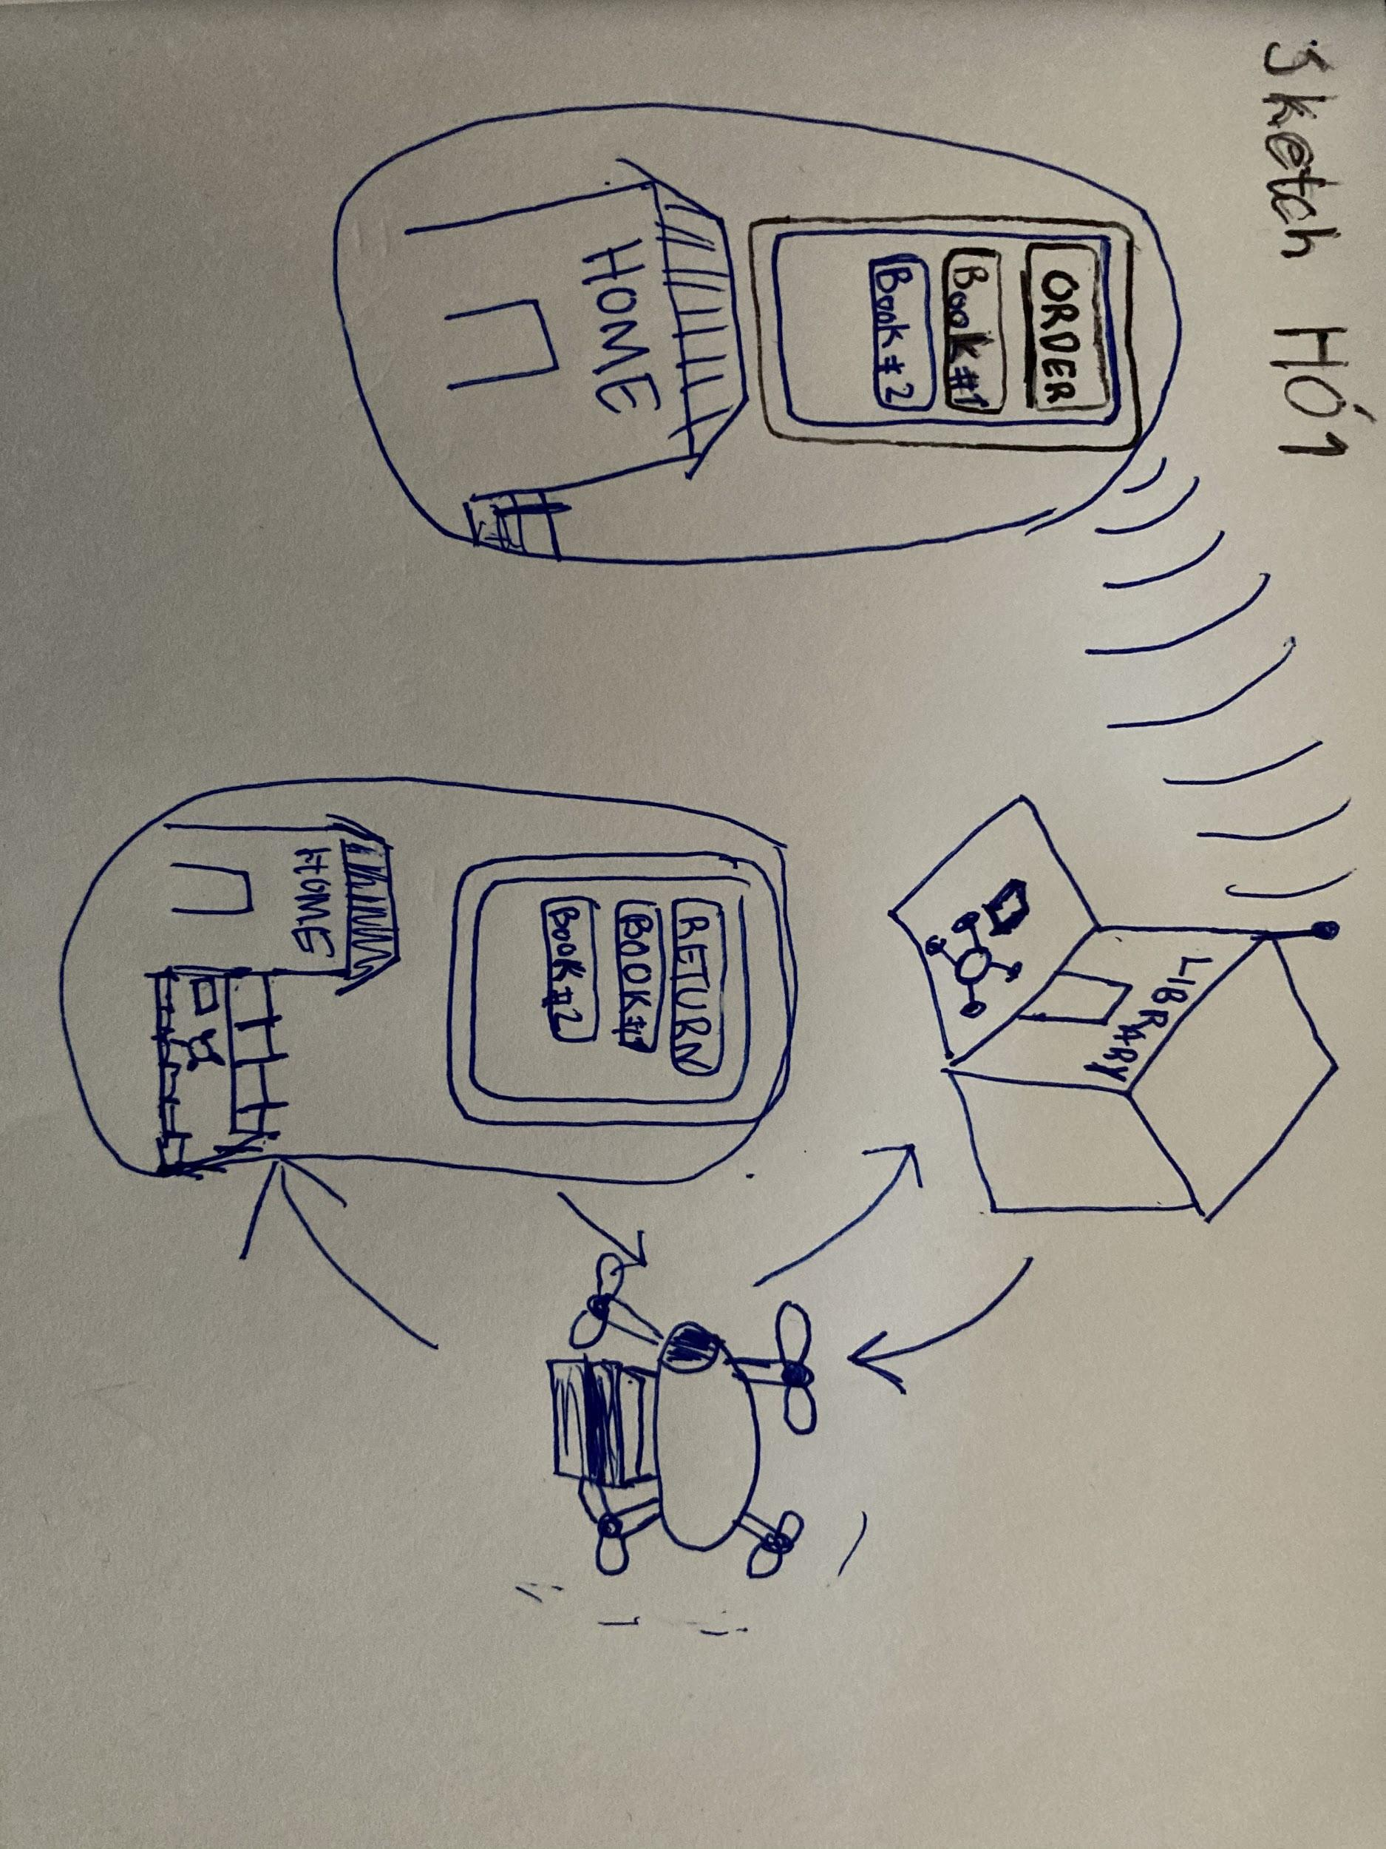

Sigríður:  
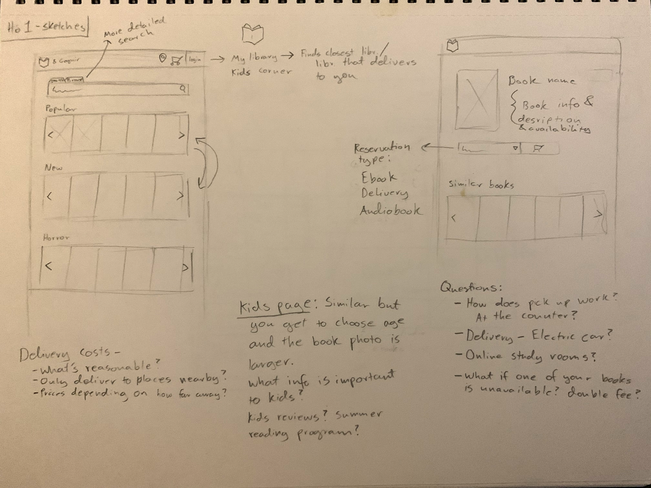

Pétur:

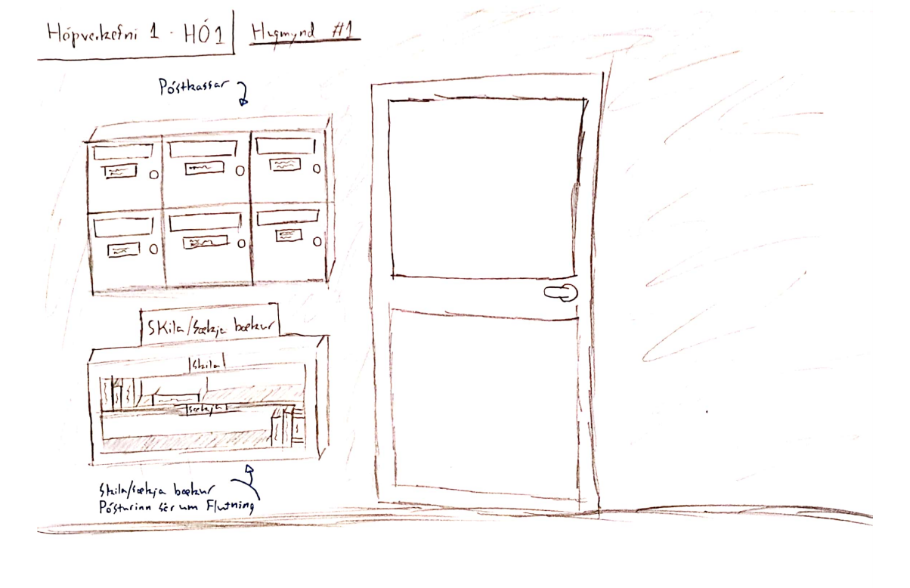

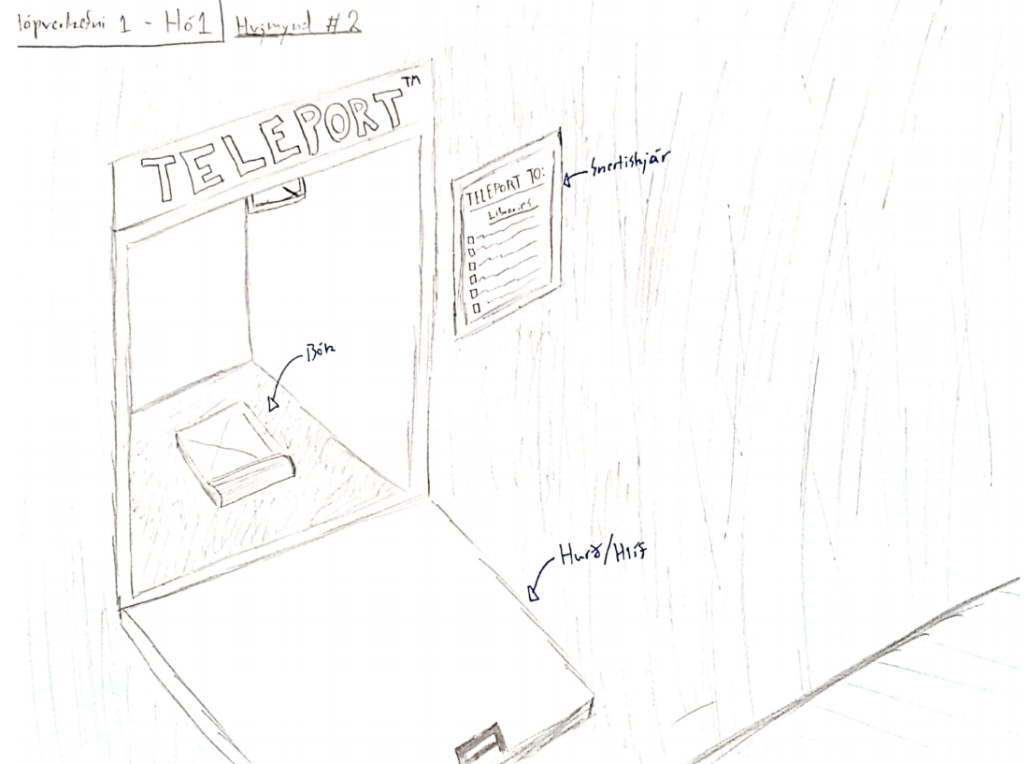

Rökkvi:  
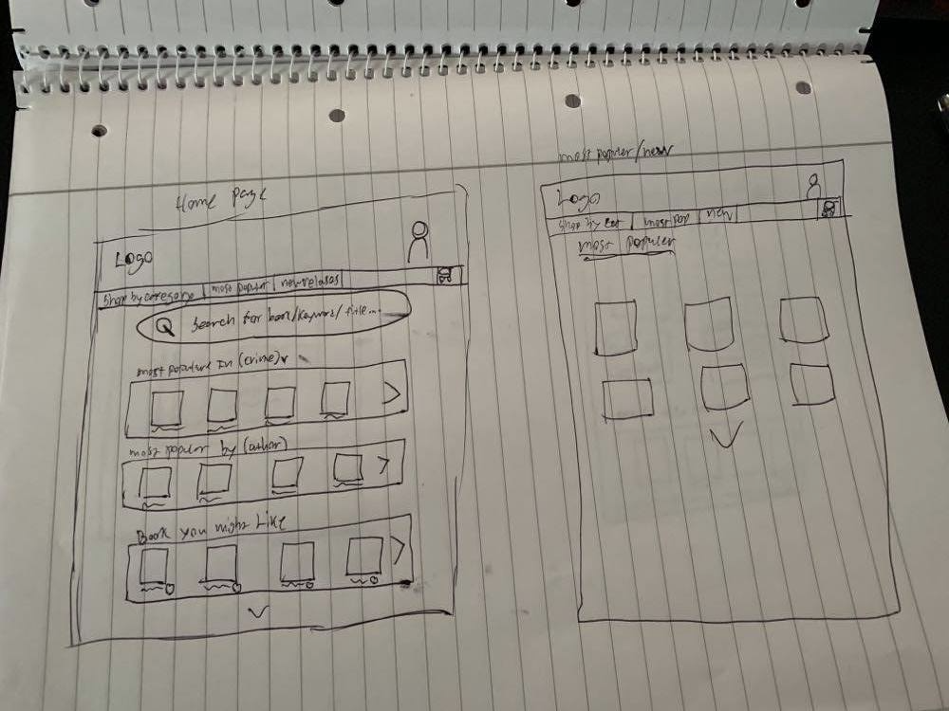

# 

# Chapter 4 - Roles

For the final round of work was doled out during the prototype meeting. Roles were chosen based on interest and abilities. Rökkvi was chosen to do the final prototype. Pétur and Kim chose the Ask/Try activities, and Sigríður was in charge of the final document.

# **Chapter 5 - The Prototype**

The idea behind the prototype was simplicity and focusing on having it user friendly. After taking the sketches and researching other similar sites I made the prototype in the application Keyword. The reason I chose Keynote was because I have used it before and I like how simple it is to use. Despite that you can make a fairly hi-fi prototype.  
Below are pictures of the prototype and text explaining each picture.

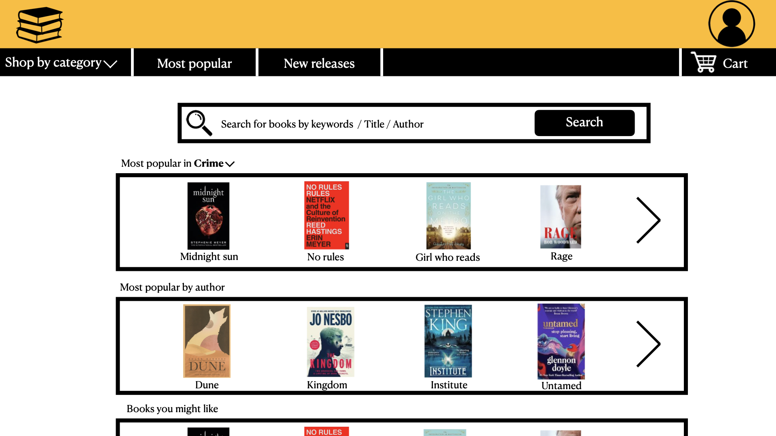

This is the front page, simplicity is the main factor of this website. The head has the logo of the page which is clickable and takes you back to the front page. You also have the user icon where users can change their information like email, phone number and home address, as well as look at previous orders. On the front page there are buttons where you can find books by category, if you click on "Shop by category" you can see the outcome on the next picture. There is a search window where you can find books by keywords and on the front page there are windows that show the most popular books. The user can change the category on "most popular in ...".  
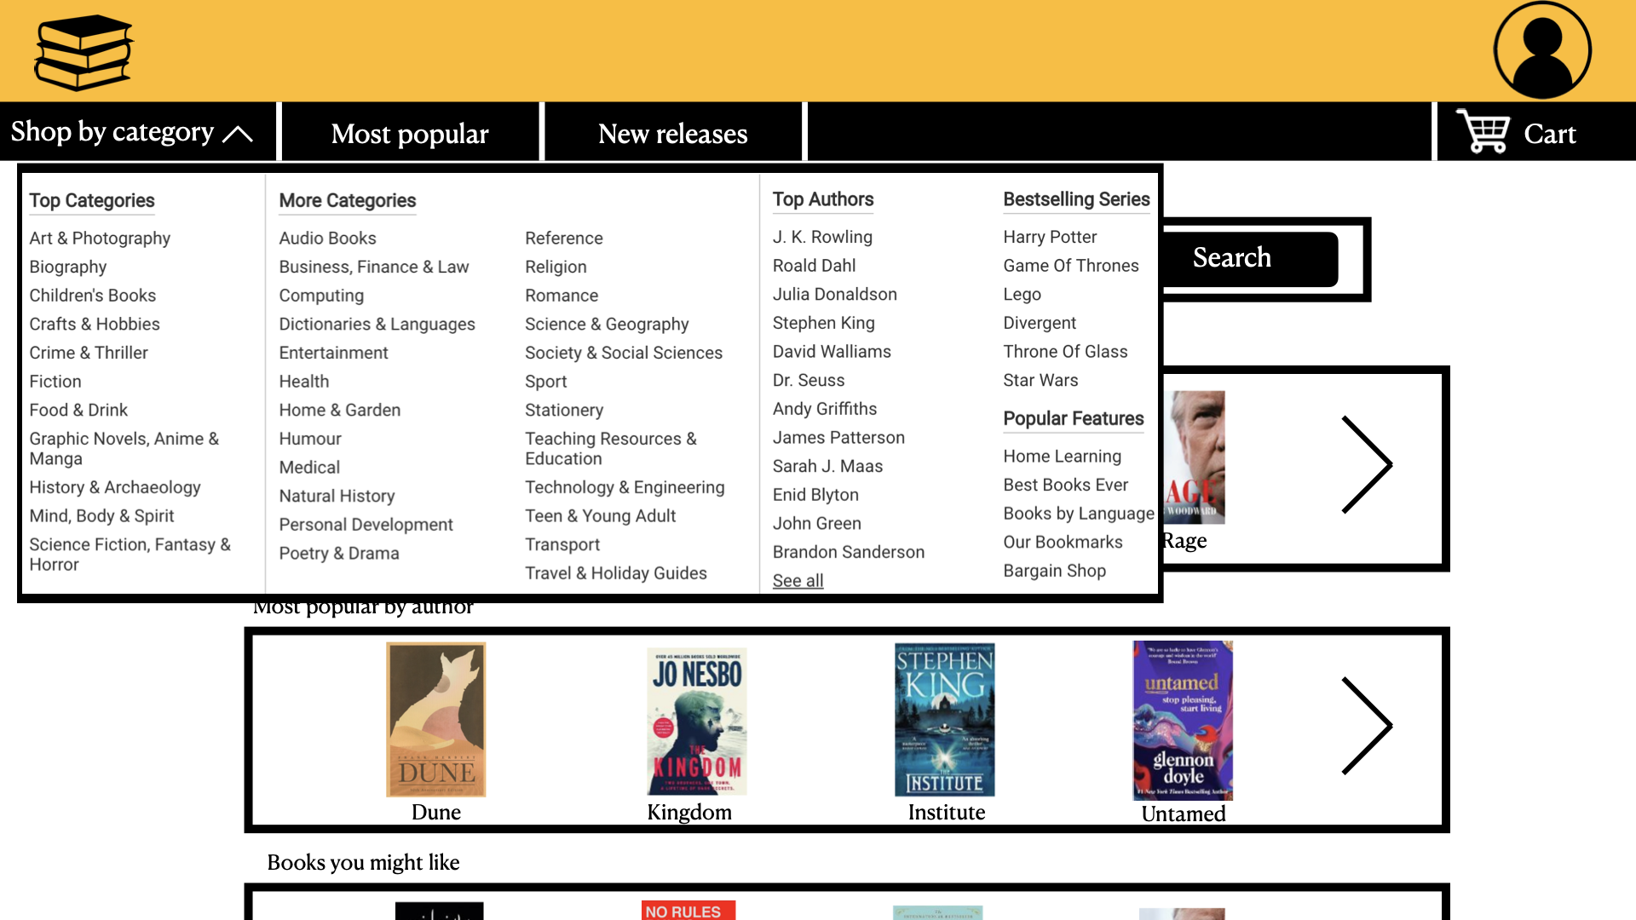  
This shows the screen after the user presses "shop by category"

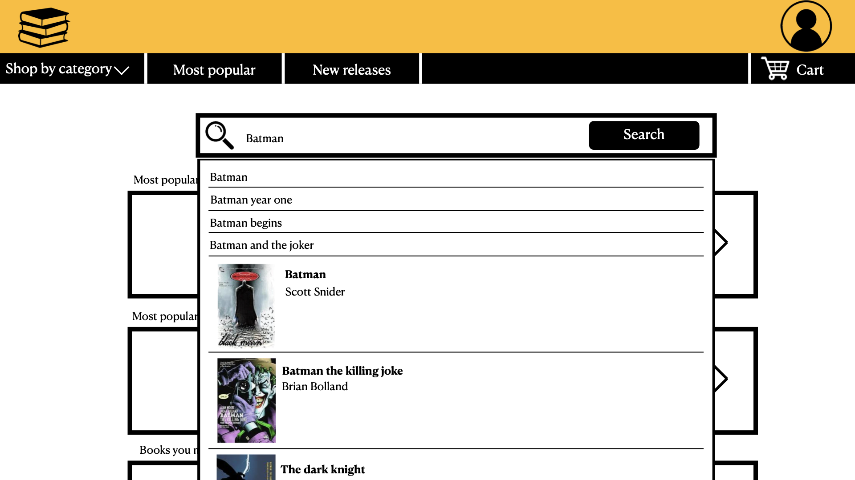  
Here is the search window. You can search by keywords or author. After inserting a word the program will look up everything related to your word.

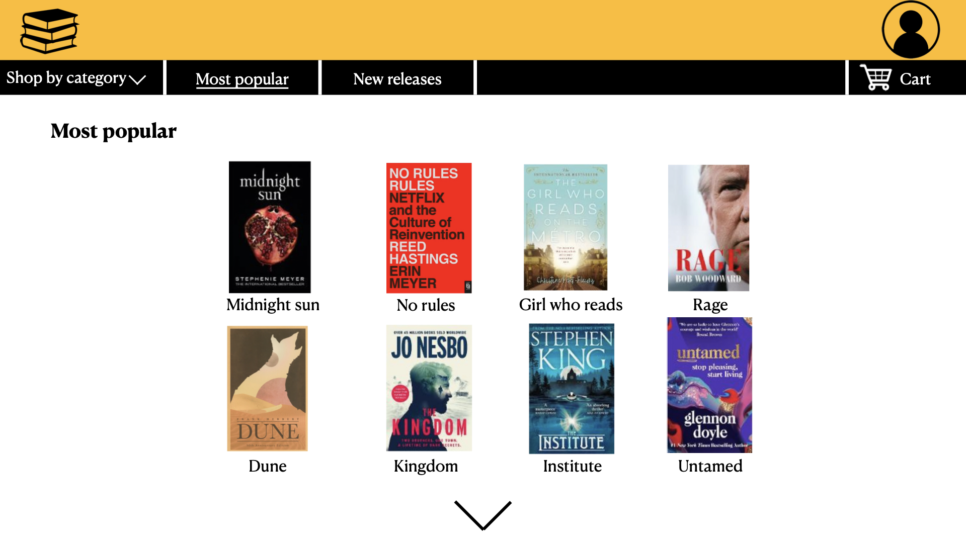  
The most popular page shows which books are the most popular right now. You can click on the arrow to get more books, and if you check the "most popular" button you see it's highlighted with the line under the title. "New releases" has the same look as most popular

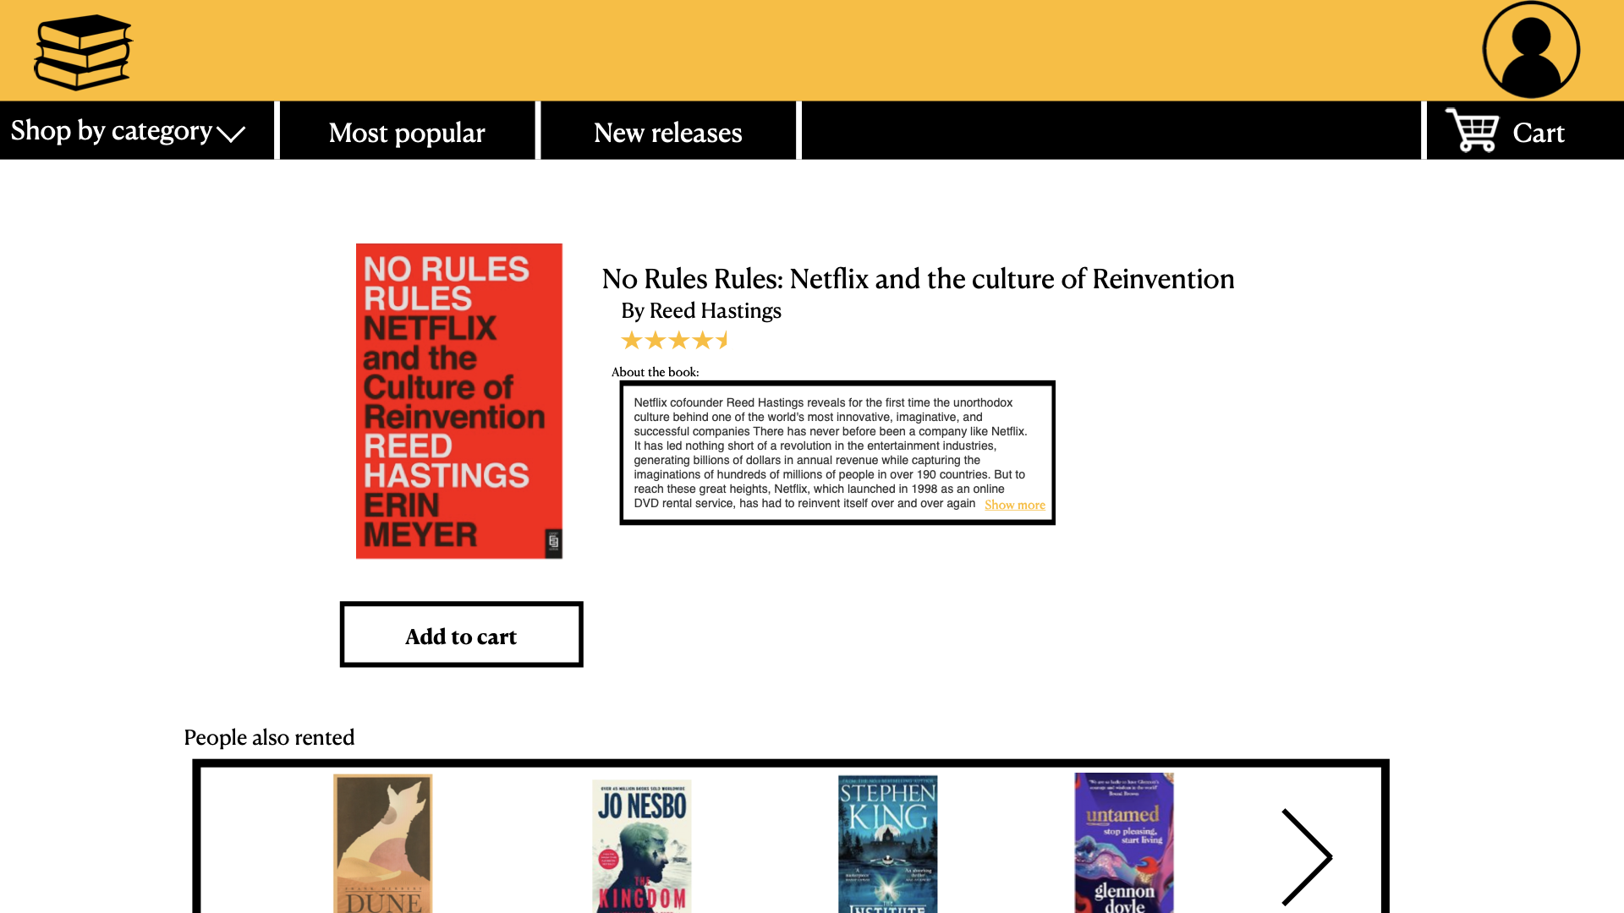

After you click a book you get the book info page where you can see everything about the book. You can add the book to your cart as well as see other recommended books.

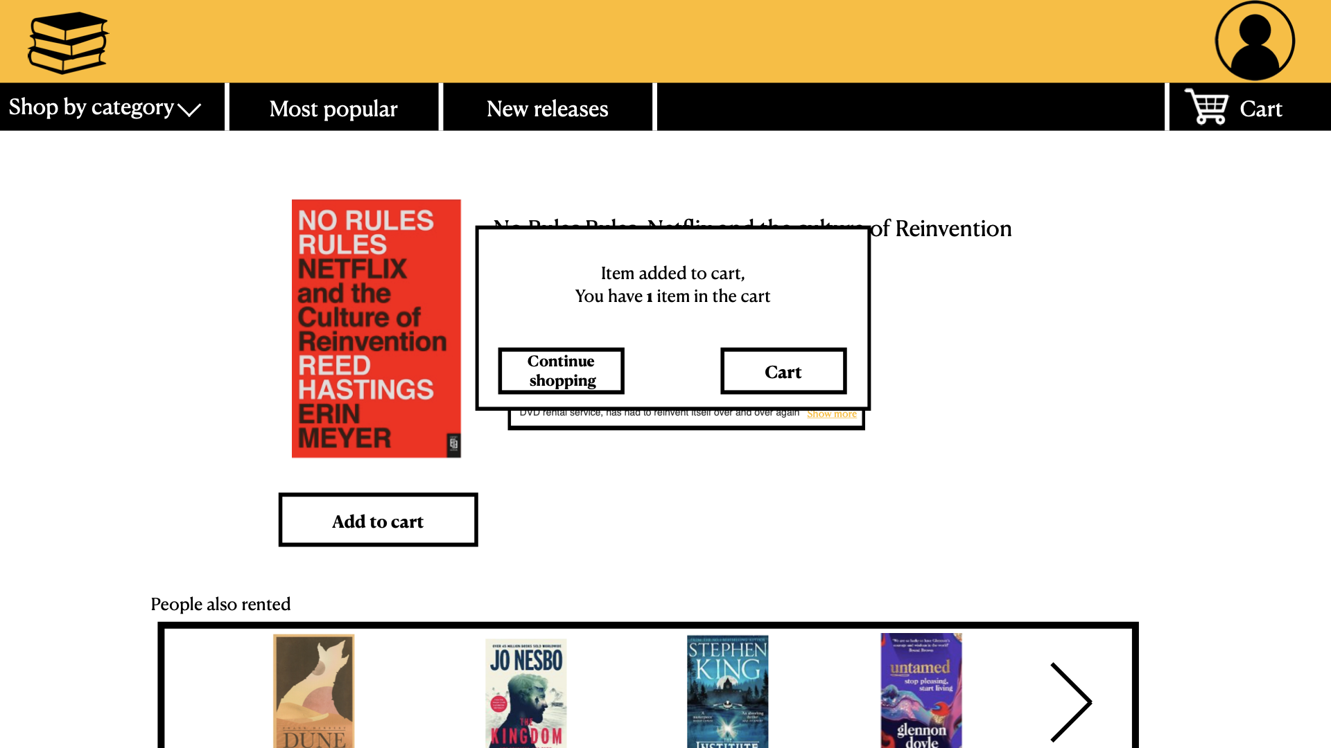

This is a pop up window that confirms that adding the book to the cart was successful.

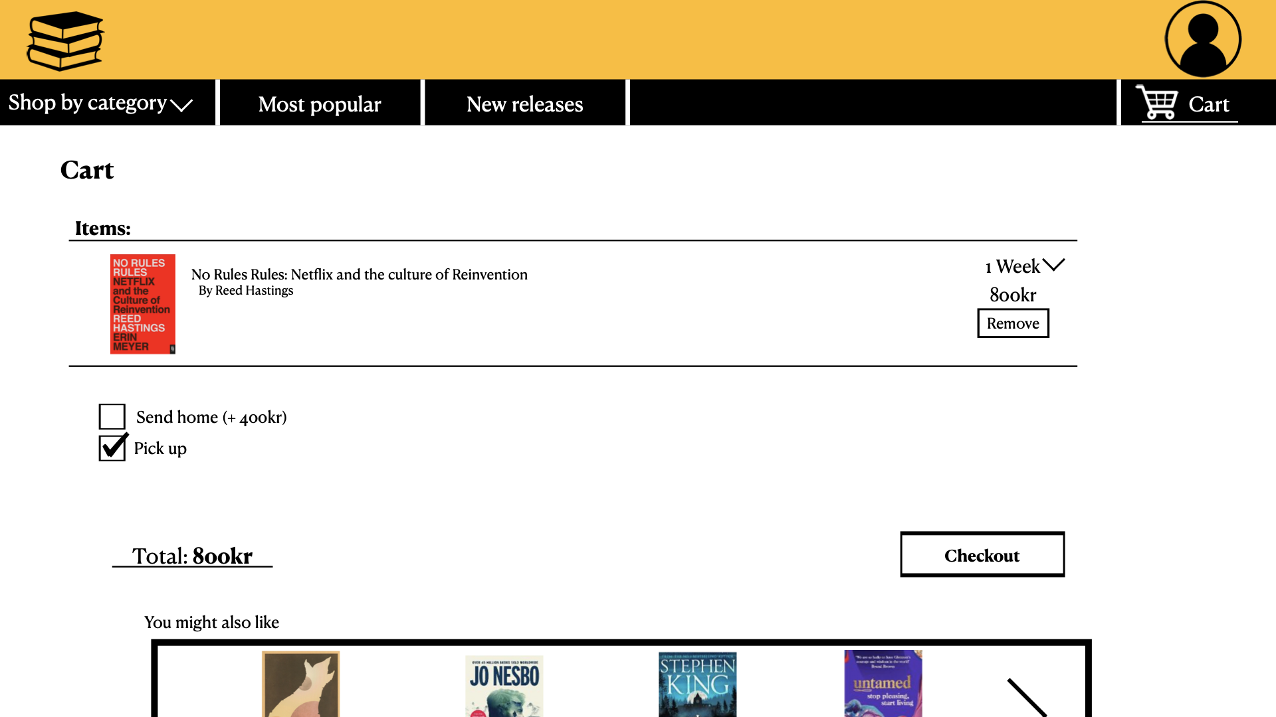

This is the cart page where you can see all the items in your cart, change how long you would like to rent the book, see the price for each book and remove them from the cart. You can choose either to pick up the book or have it sent to your home address, there is also a total amount for the cart and see recommended books.

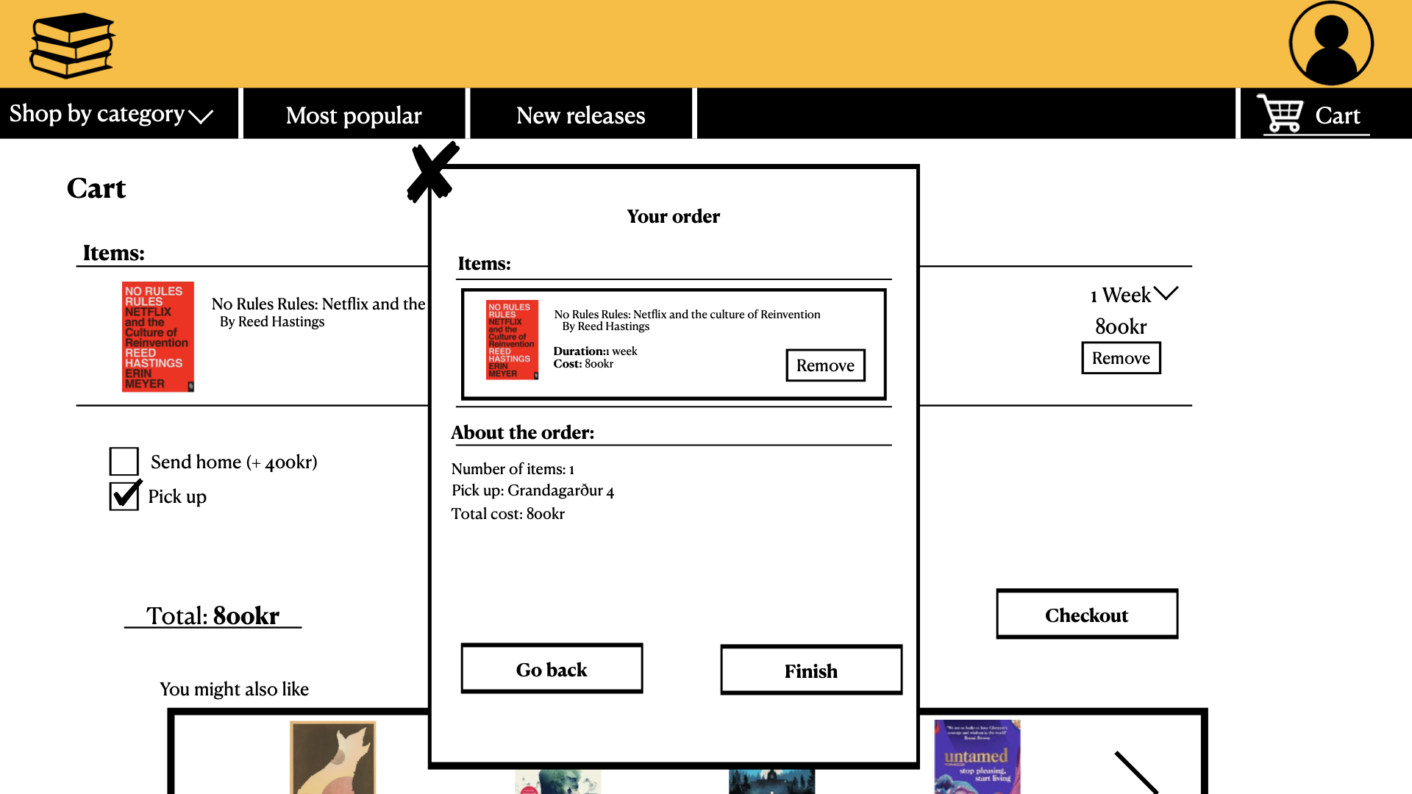

After you press checkout you get your order page where has all the information for your order.

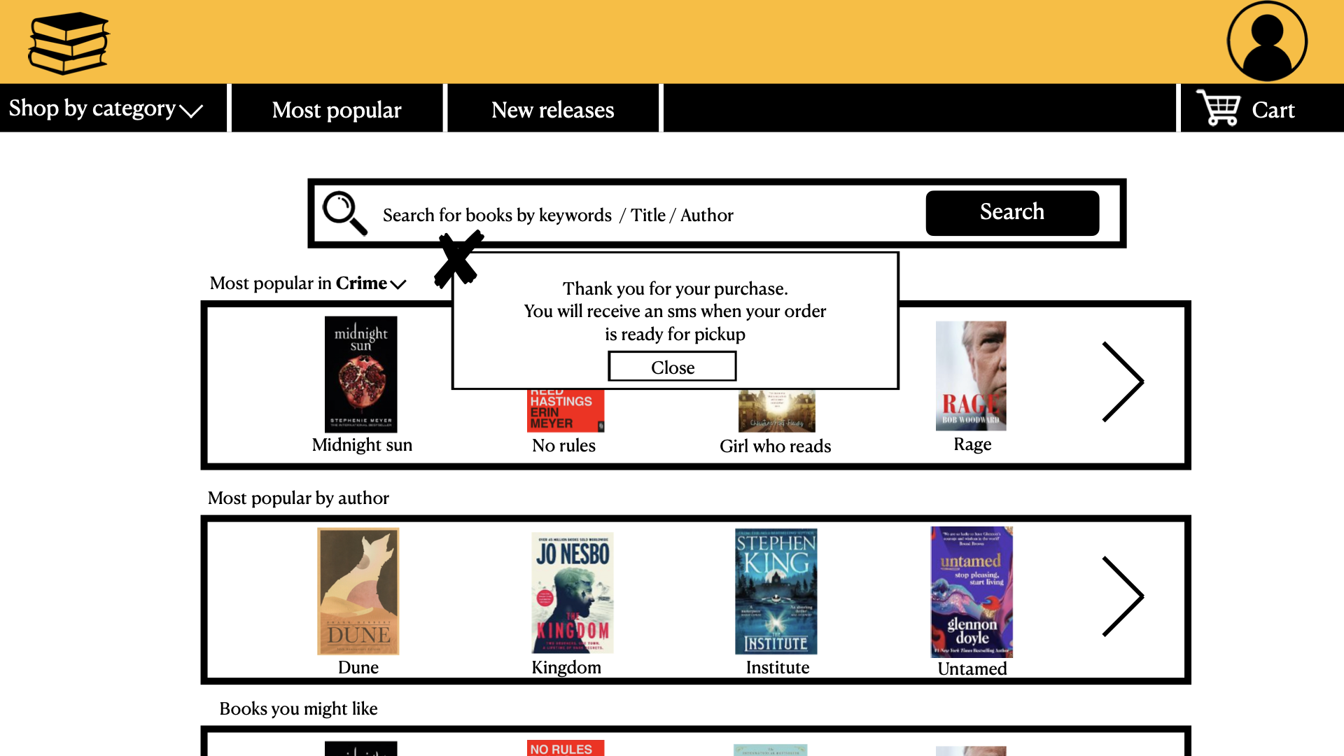

After pressing finish on your order page you get a confirmation.

# **Chapter 6 - Test**

## Ask method - Surveys & Questionnaires - Pétur

The Ask activity that I chose is called “**Surveys & Questionnaires**”.

The activity consists of asking a large number of people a series of specific questions in order to gain insight into the users themselves. According to the IDEO cards this is a useful way to question and gain answers from a large number of people in the shortest time possible.

The survey was made using ***Google forms***.

### Types of questions:

* **Multiple Choice**
  + Users can only select one answer out of multiple available.
* **Checkboxes**
  + Users can select as many answers as apply to them.
* **Paragraph**
  + Users can write their own answers.

### The Survey

The following questions were included in the survey:

1. Do you read books in your free time?  
**(Multiple choice)**

1. Yes
2. No.
3. Sometimes.

2. Where do you usually find books that you are interested in? Choose as many as you like  
**(Checkboxes)**

1. Online.
2. Library.
3. Book store.
4. Through friends or family.
5. I don't like reading books.
6. Other...

3. If it applies, where do you usually get your books? Choose as many as you like  
**(Checkboxes)**

1. Order online.
2. Library.
3. From friends or family.
4. Book store.
5. I don't.
6. Other...

4. How do you like reading your books the best?  
**(Multiple choice)**

1. Physical copy.
2. Reading devices, such as Kindle.
3. Audiobook.
4. On your personal computer.
5. Other…

5. On average, how often do you go to the library?  
**(Multiple choice)**

1. Every Day.
2. A few times per week.
3. A few times per month.
4. A few times per year.
5. Never

6. If you do, why do you go to the library?  
**(Multiple choice)**

1. School.
2. Research.
3. Find a book I'm interested in.
4. I don't go to the library.
5. Other…

7. How would you evaluate your overall experience when going to the library?  
**(Multiple choice)**

1. Really good.
2. Good.
3. Neutral.
4. Bad.
5. Horrible.

8. Would you be more likely to borrow a book from the library, if the book could be delivered to your home?  
**(Multiple choice)**

1. Yes.
2. No.
3. Other …

9. Is there anything that would encourage you to read more books?  
**(Paragraph)**

Answers marked with “**Other…”** offer the user to write in their own answers freeform.

### Survey outcome

There were 23 responses to the survey.

The answers were the following:

**1.** **Do you read books in your free time?**

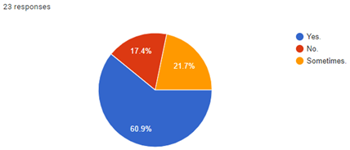

**2.** **Where do you usually find books that you are interested in? Choose as many as you like**

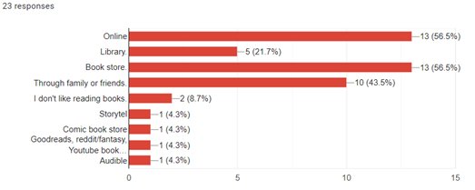

**3.** **If it applies, where do you usually get your books? Choose as many as you like**

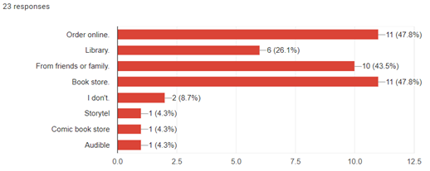

**4.** **How do you like reading your books the best?**

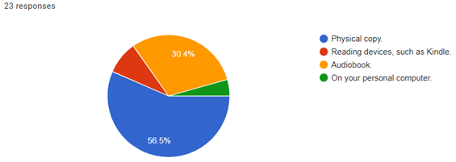

**5.** **On average, how often do you go to the library?**

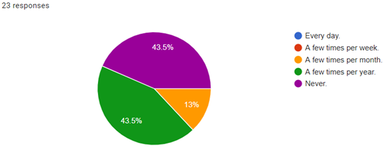

**6.** **If you do, why do you go to the library?**

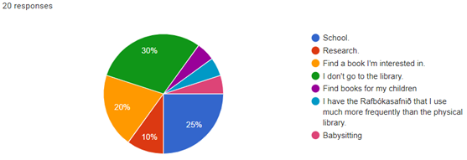

**7.** **How would you evaluate your overall experience when going to the library?**

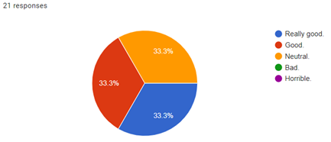

**8.** **Would you be more likely to borrow a book from the library, if the book could be delivered to your home?**

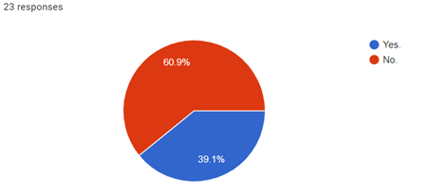

**9.** **Is there anything that would encourage you to read more books?**

15 people answered this question with the following answers:

***Answer***: No  
***Answer***: No.  
***Answer***: If I had a specific time of the day to read  
***Answer***: Free time and holydays  
***Answer***: More time  
***Answer***: more free time :D  
***Answer***: Getting paid to read them  
***Answer***: Not having to work!  
***Answer***: More time to read  
***Answer***: more advertising  
***Answer***: Less access to the internet....  
***Answer***: No please, I have too much to read, no more please!  
***Answer***: Audible has been the best encouragement so far, I can listen to roughly 10 books in one month.

### Results

The results from the survey were interesting and more people answered the survey than was expected.

I think giving the users the possibility of adding their own answers using the “**Other…”** option was a good idea. Seeing the different answers added gives us further insight into the users’ habits and further ideas into where we could take our prototype in the future.

The survey results give us a few new ideas that would be good for the next stages of the prototype. For example according to question 2 most people find the books they are interested in online, through family and friends or from the book store. Thus, it could be a good idea to make friend recommendations, book reviews and best sellers lists show up on the site to direct users towards books they could be interested in.

Another idea would be to include audiobooks in the library since according to question 4, the second most popular way of ‘reading’ books was to listen to them through audiobooks.

Overall, I think the survey was successful. There were more participants than was expected, good answers and we were commended a few times on having a short survey that didn’t take the users too much time to answer.

### 

## Ask method - Extreme User Interviews - Kim

### Description and Motivation

The chosen Ask Activity was Extreme User Interviews. The card wants one to interview different people at different extremes and evaluate what their experience with the prototype is.

By allowing extremes to evaluate the prototype we can discover unanticipated and key issues that our anticipated target audience might not be so quick or able to point out. For our book rental prototype it would be beneficial to look at those who never go to the library and those who frequent the library and see what their experiences with book rentals and libraries can say about our prototype.

### Using the Activity

For the activity it was decided to interview two extremes: one who almost never goes to the library and one who does so frequently.

The first person to be interviewed was the person who never (read: very rarely) went to the library. Their opinion of the prototype was that it seemed intuitive to use and a more attractive alternative compared to the library. The ways that made it more attractive were that they would not have to go out of their way to get to the library and also that they could more efficiently browse for books.

It was however mentioned that while they might consider *trying* the service they have strong doubts that they would keep using it because the main reason they don’t go to the library is because they are not an avid reader and not necessarily due to the impracticality or dislike of the library itself. They were however keen to point out that if they do read a book they would much prefer it to be physical rather than digital.

The second person to be interviewed was the person who frequents the library. When shown the prototype they showed great interest. They were quick to mention that they live far away from a library of decent size and as such a service like this could really help cut down on trips to the library.

When asked if they would want to use the service they said that they would, but they also pointed out that they would probably not use it all the time. The reason for this was that the library itself provided “the perfect space for browsing and reading books”. They mentioned that the library was also a meeting place. In other words they said that the library had a value beyond just the individual books that it stored.

### Results

The interviews showed that neither “extreme” user was extremely keen on the prototype (which is many times to be expected).

The key takeaways from the first interview was that people who don’t go to the library may very well do so simply because they don’t care for reading books. As such it should be considered that we are not trying to sway those who don’t go to the library to use our solution, but rather simply focus on the people who read books, no matter if they use or don’t use the library.

The second interview provided insight into the values of the library beyond the books that it stores. The prototype could develop in ways to provide substitutes for some of the services that libraries provide (other than book rentals). Examples of these services would be the library as a meeting place and the help provided by librarians.

# **Chapter 7 - Conclusion**

From the activities above we can see that there is a market for a product such as this. In the surveys more than 40% of the people polled said they would likely use the service, and in the user interviews both the participant who regularly visits the library and the one who almost never does showed interest in the prototype though how frequently it would be used is another matter.

The questionnaire offered several good insights on what we might want to add to the prototype. Many of the participants get their book recommendations from friends and book reviews so including a feature to see what your friends are reading and what they recommend would be a good addition.

Our interviewee who frequents libraries touched on the other uses of libraries as a social hub which was also discussed further in the Character Profiles Look activity. Perhaps with the current situation of the virus, there is even more of a reason to offer services such as this. Libraries are restricting access to the buildings so many of their services are unavailable. Because of this the main reason for people to visit is solely to borrow books so this service would be a time saver to many. A delivery option would also reduce the traffic of potentially infected people to the library.

On the whole the group worked very well together. Everyone seemed very interested in the assignment and added their own spin to it. Everyone turned in their parts on time. Group meetings went well and everyone got to offer their opinions on how the final prototype should look.

For the next assignment a few changes were discussed. Since this was a relatively straight forward project there wasn’t much need for using Asana. Perhaps in the next assignment something simpler could replace it such as a shared google document with information on what’s been done so far and who’s doing what. Sigríður expressed that they would like to keep better notes during group meetings in the next assignment as there were a few things discussed they forgot during the final drafting.